CSL 7020 Assignment 4

Ashutosh Kumar Jatav (B16CS004)

## Dataset

* Used Face-data set

## Approach

1. Normalize the data
2. Calculate mean and centre the data
3. Calculate covariance matrix
4. Compute eigen vectors with corresponding eigen values
5. Sort eigen values
6. Select first k eigen values
7. Compute the compressed image by dot product of top k eigen vectors and original image.
8. Recover the original image by dot product of compressed image and top k eigen vectors

## Experiments

* Top K values are reduced by factor of 2 and result has been analysed initial eigen vector matrix has dimension of 1048
* These reconstructed images can be further be used for tasks like classification etc so we can compute on lower computation with required features from PCA

## Analysis

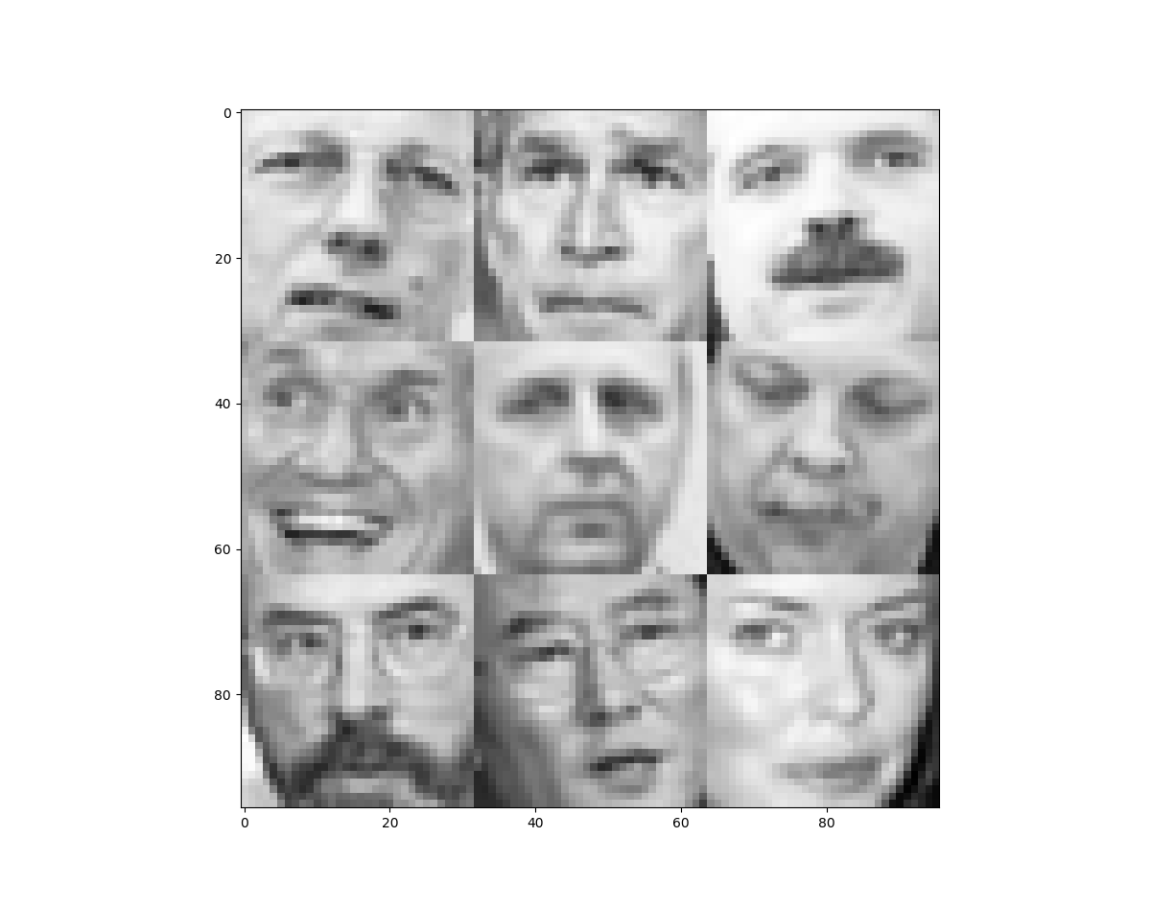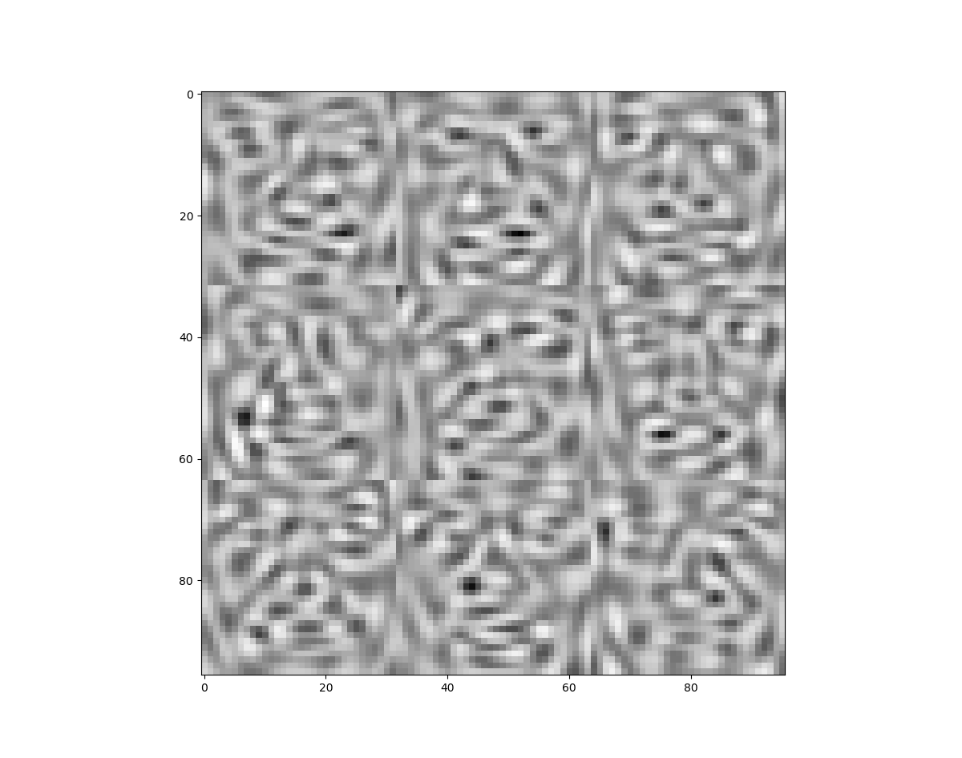

Figure : Original Faces Figure : Eigen Faces

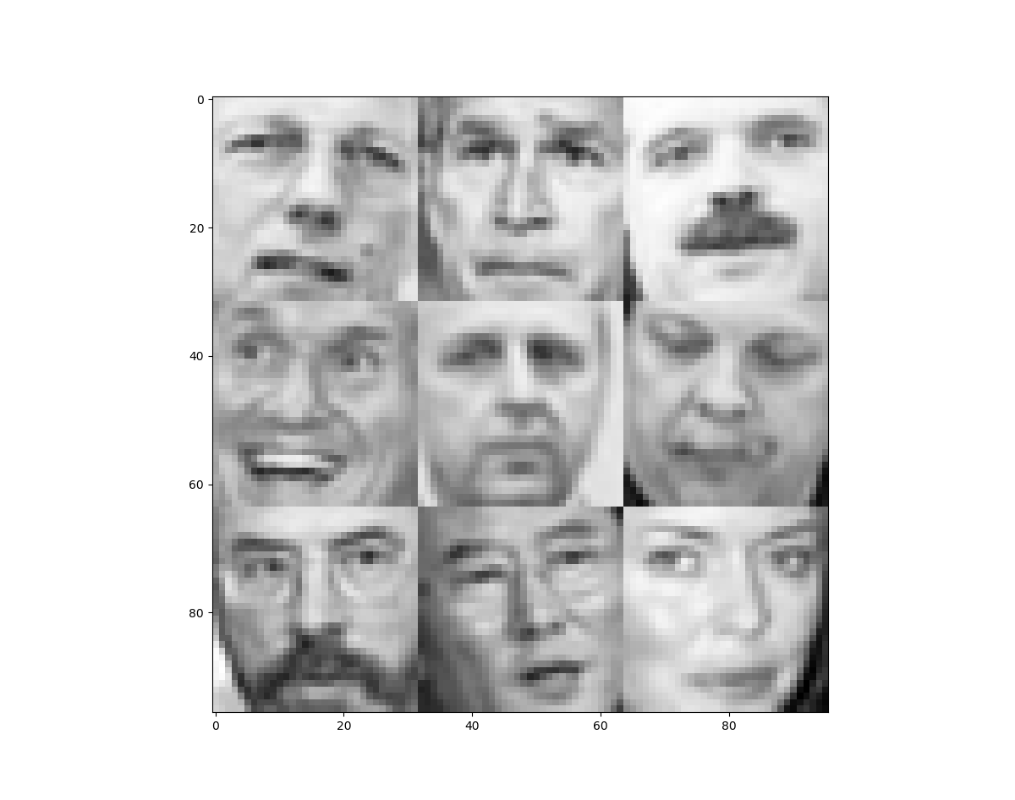

Figure : 100% components Figure : 50% components

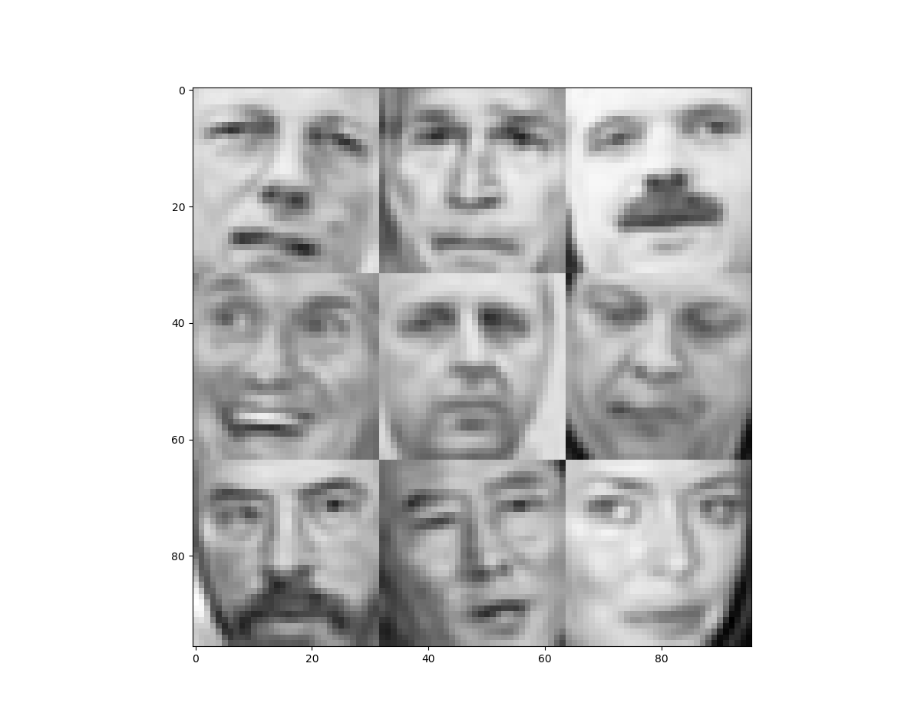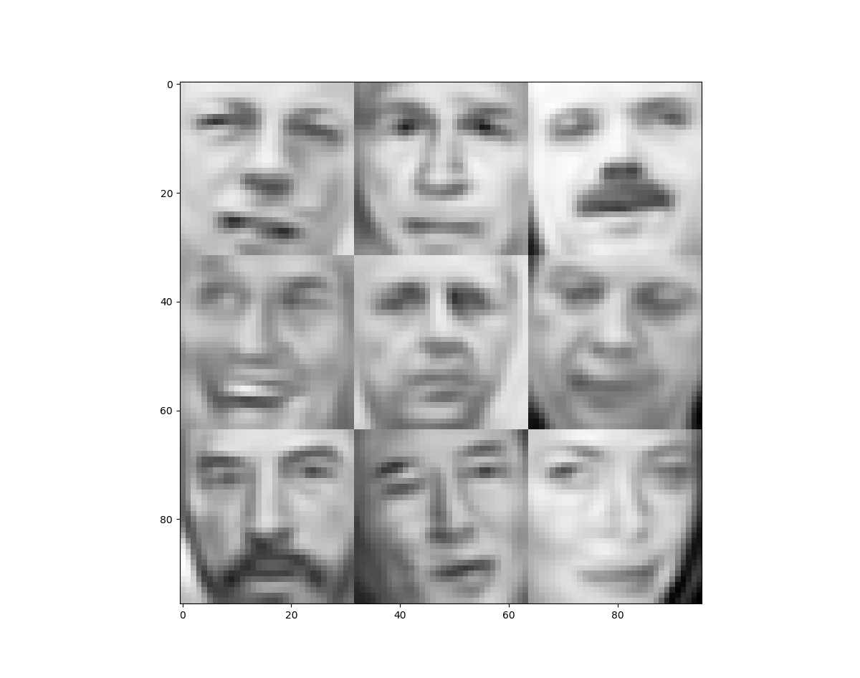

Figure : 25% components Figure : 12.5% components

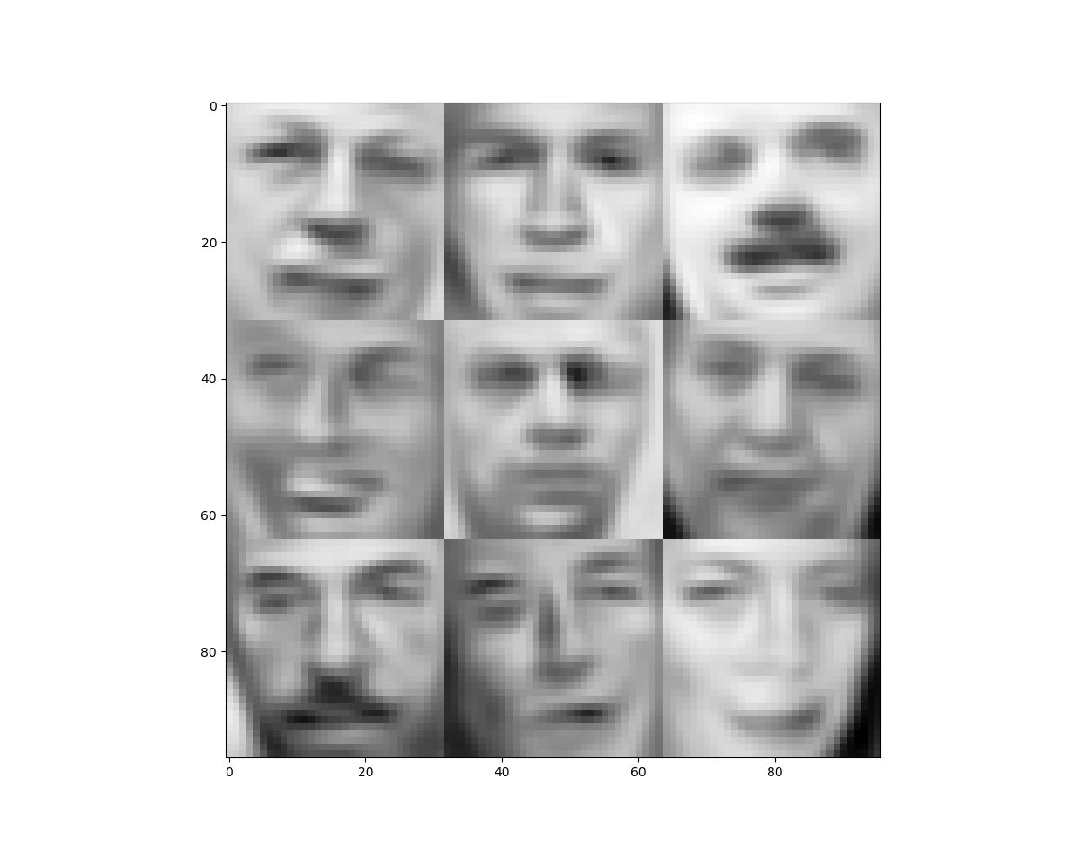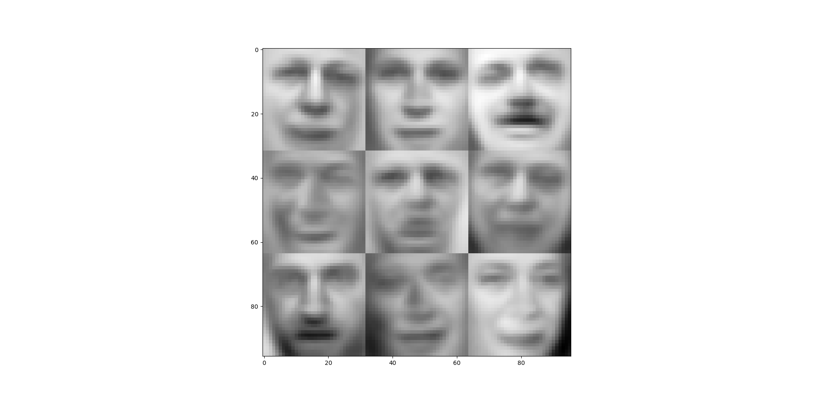

Figure : 6.25% components Figure : 3.2% components

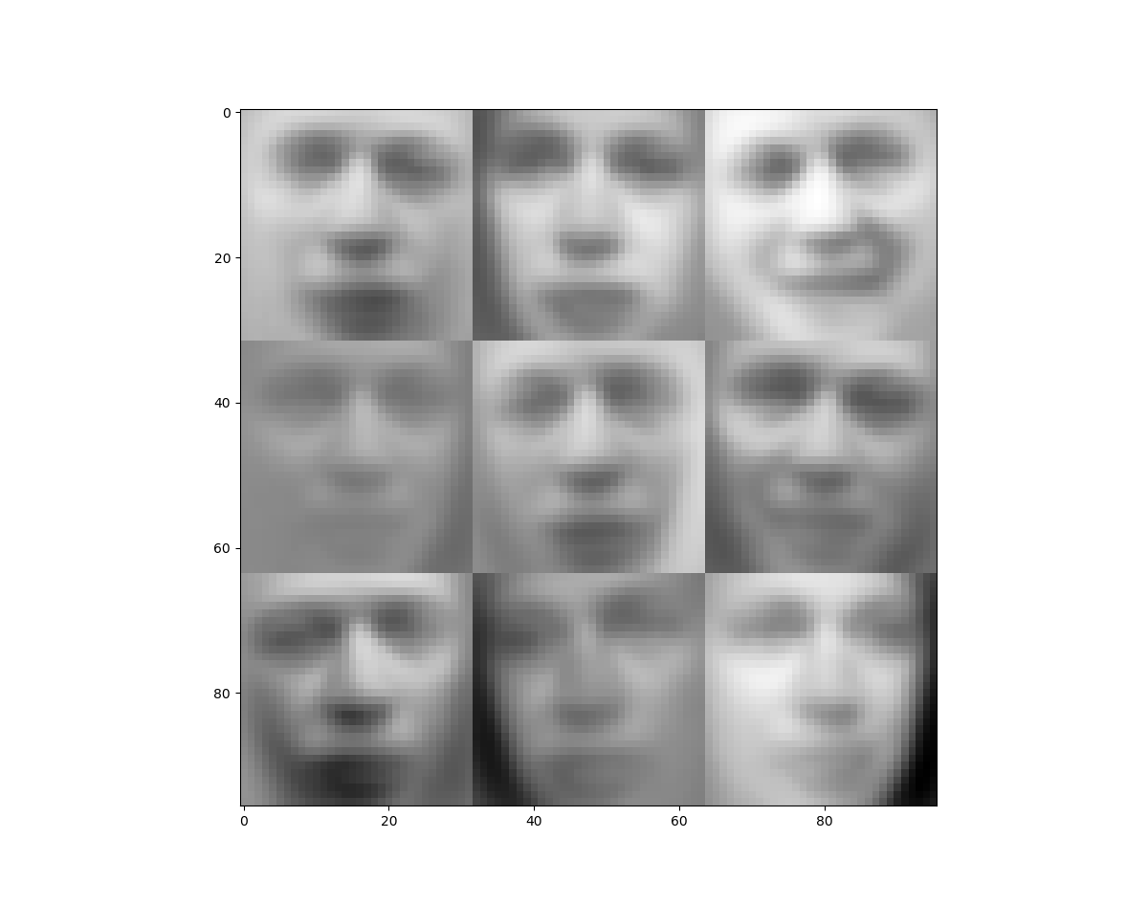

Figure : 1.2 % co

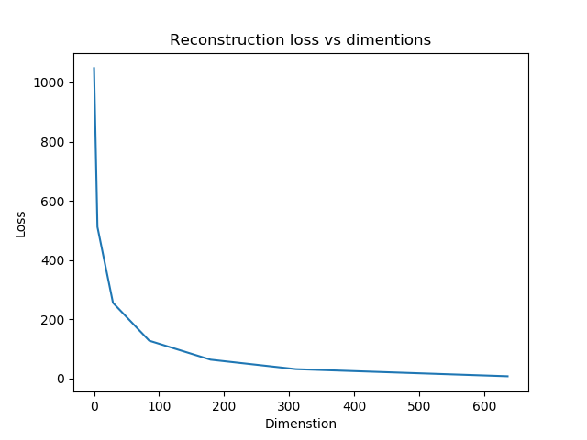mponents